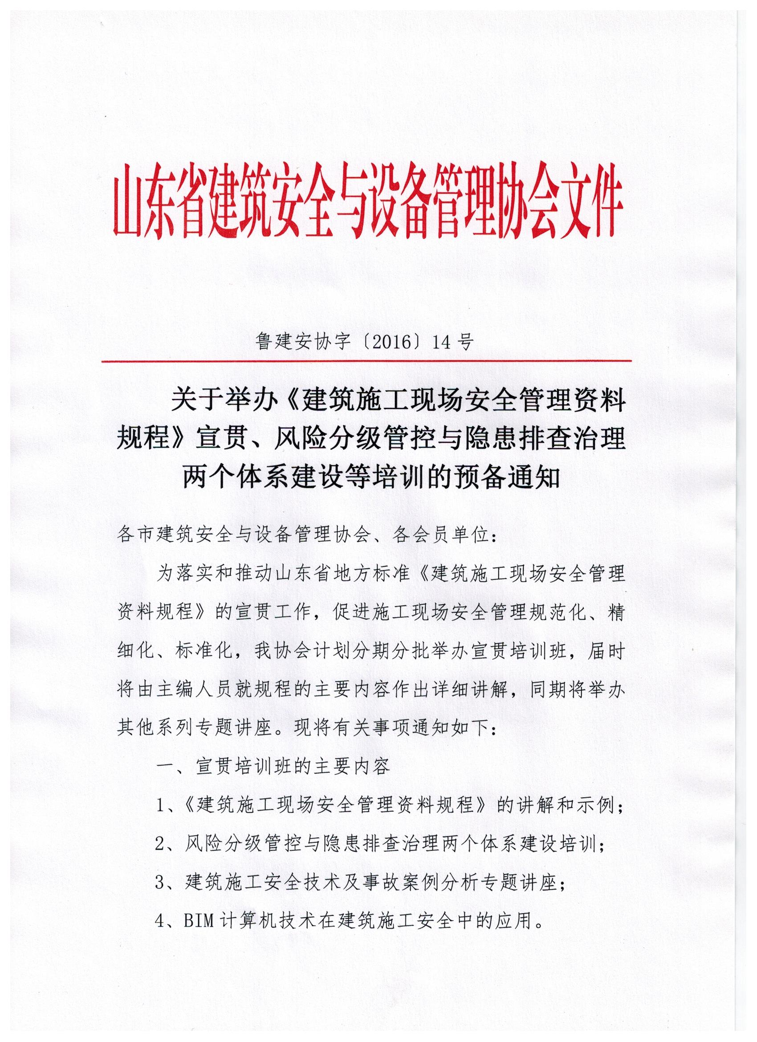

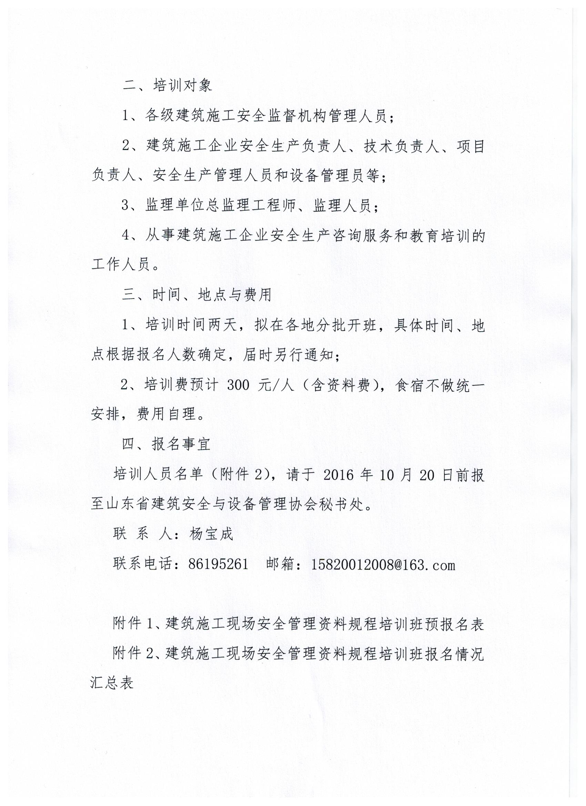

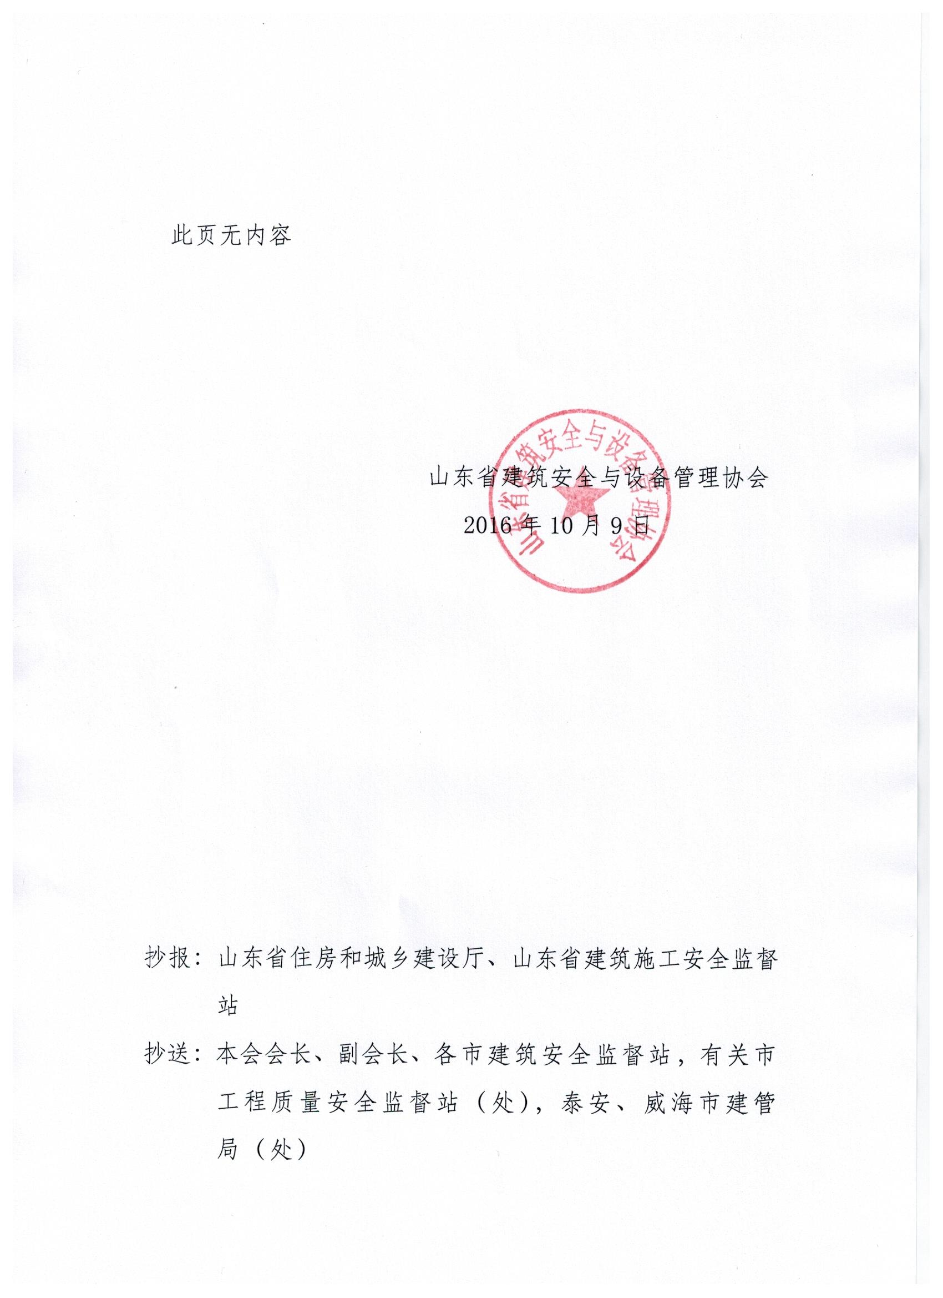

附件1

建筑施工现场安全管理资料规程培训班预报名表

|  |  |  |  |  |  |
| --- | --- | --- | --- | --- | --- |
| 单位名称 |  | | | | |
| 联 系 人 |  | | | 手机 |  |
| 姓名 | 性别 | 部门 | 职务 | | 电话（手机） |
|  |  |  |  | |  |
|  |  |  |  | |  |
|  |  |  |  | |  |
|  |  |  |  | |  |
|  |  |  |  | |  |
|  |  |  |  | |  |
|  |  |  |  | |  |
|  |  |  |  | |  |
|  |  |  |  | |  |
|  |  |  |  | |  |

注：此表由参加培训单位填报，报所在市建筑安全监督机构；

附件2

建筑施工现场安全管理资料规程培训班报名汇总表

市

|  |  |  |  |  |  |
| --- | --- | --- | --- | --- | --- |
| 序号 | 姓名 | 性别 | 企业名称 | 职务 | 联系电话 |
|  |  |  |  |  |  |
|  |  |  |  |  |  |
|  |  |  |  |  |  |
|  |  |  |  |  |  |
|  |  |  |  |  |  |
|  |  |  |  |  |  |
|  |  |  |  |  |  |
|  |  |  |  |  |  |
|  |  |  |  |  |  |
|  |  |  |  |  |  |
|  |  |  |  |  |  |
|  |  |  |  |  |  |

注：此表可复制