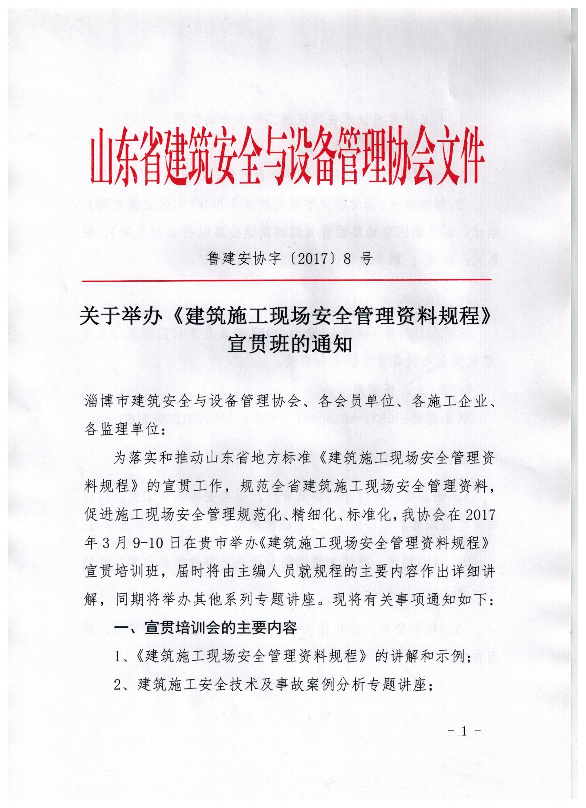

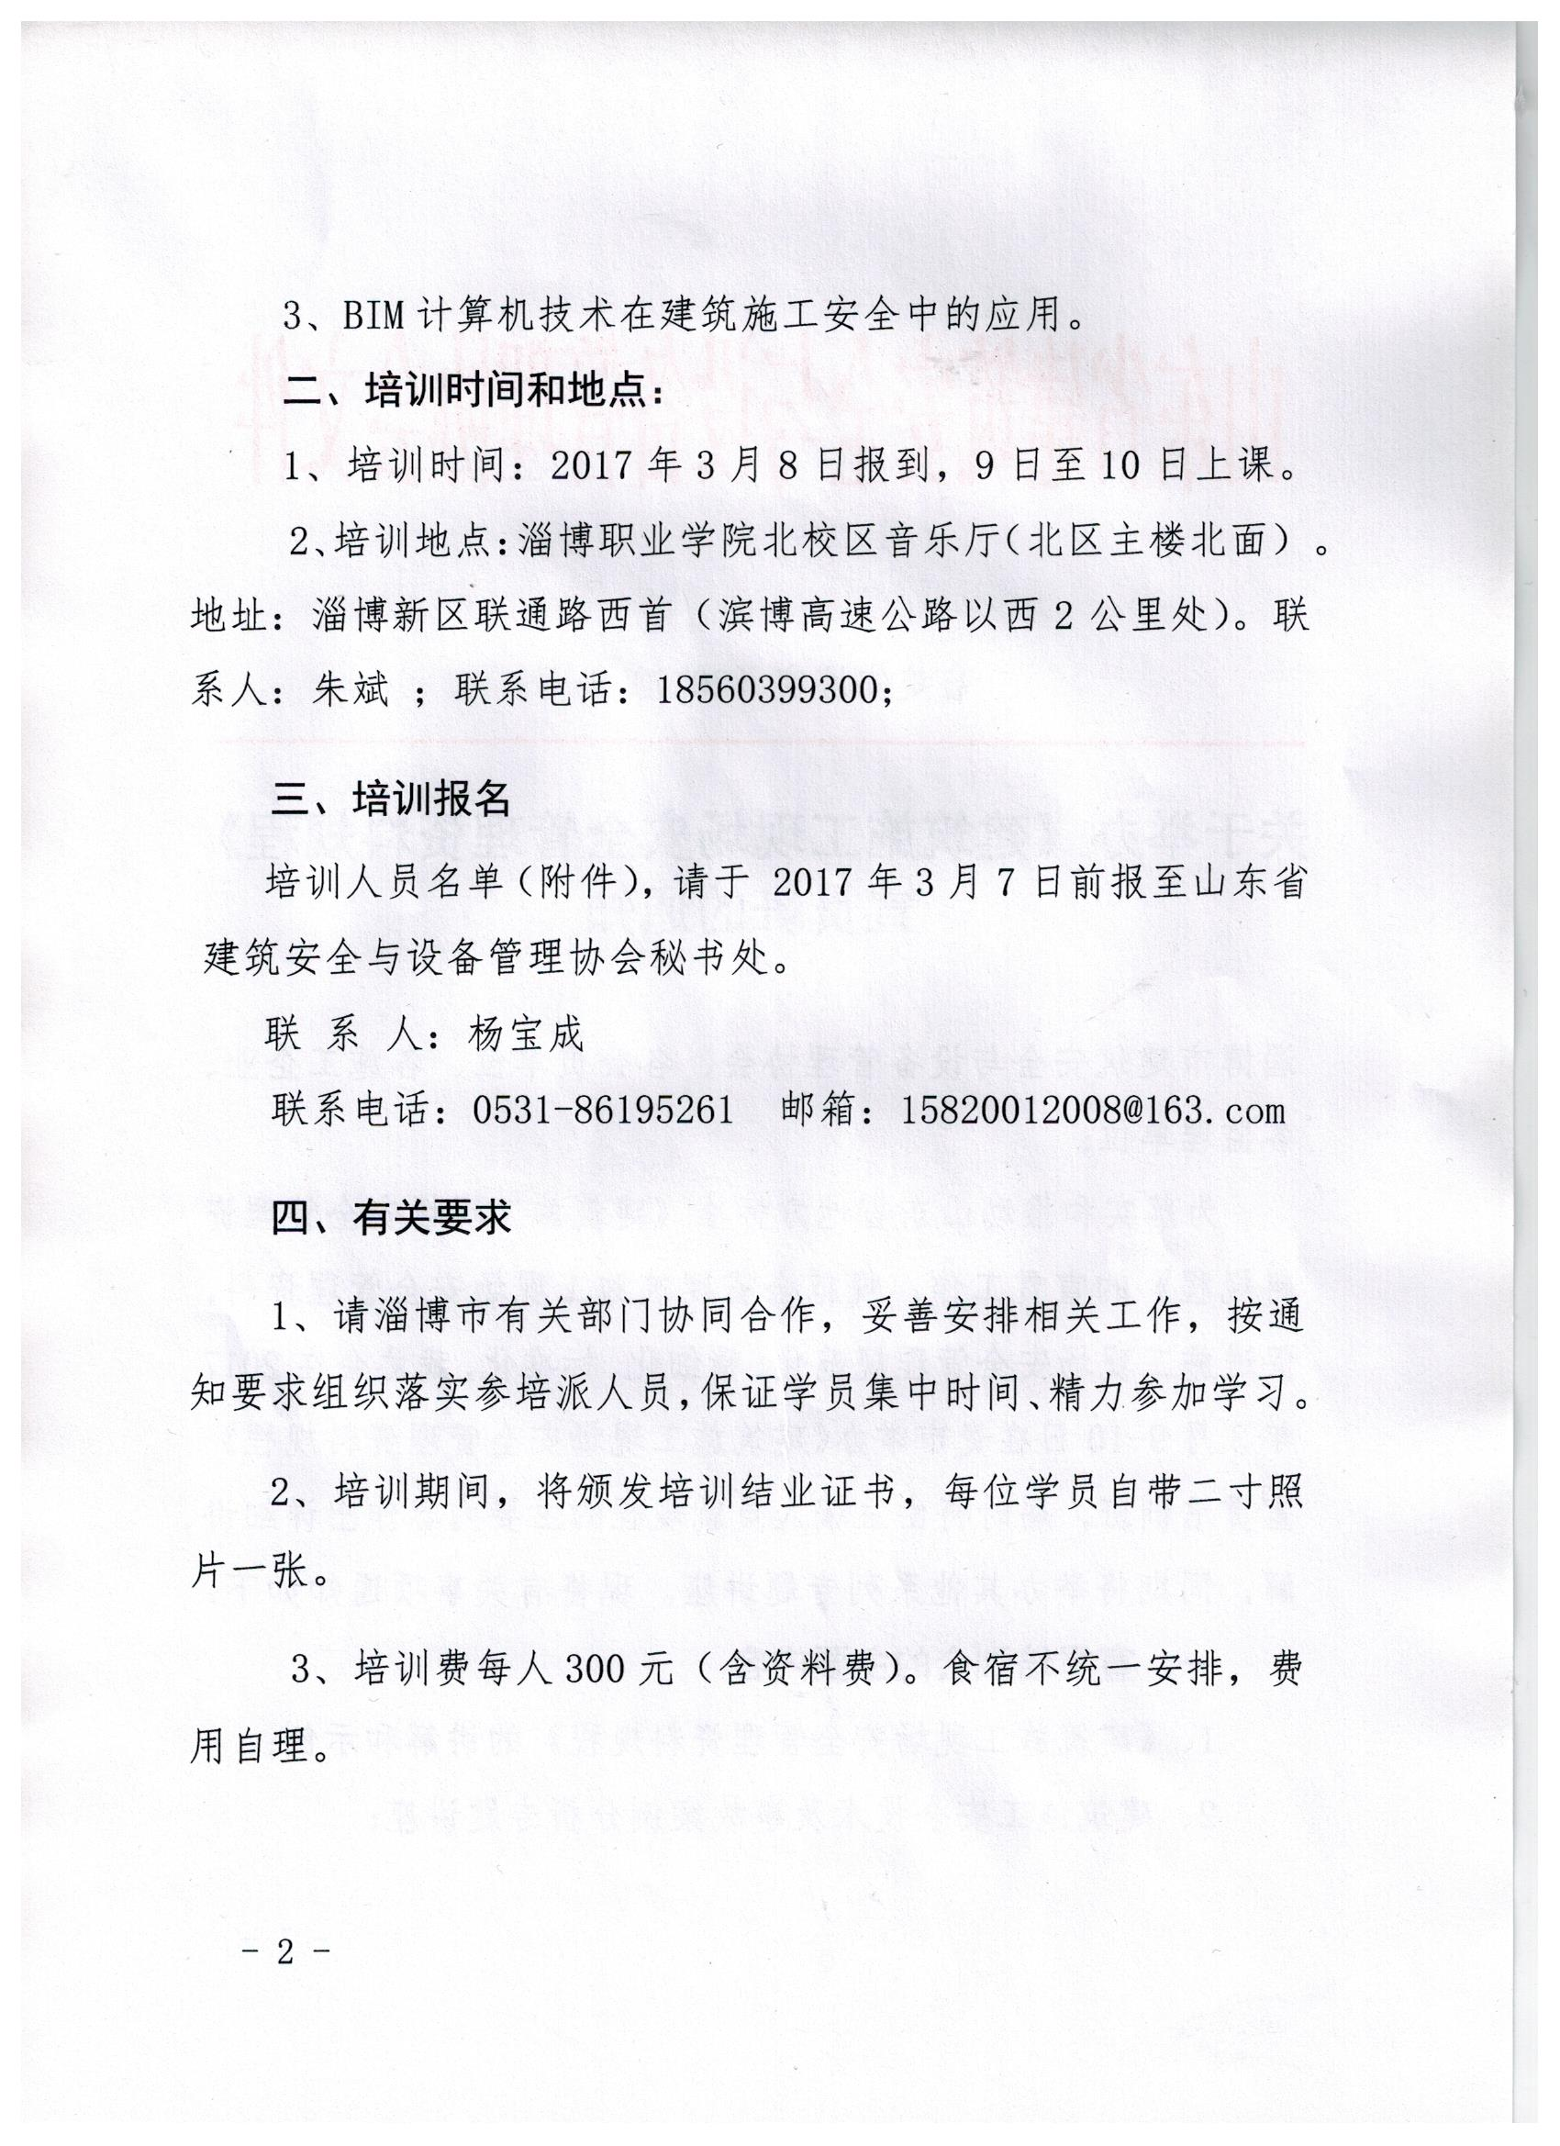

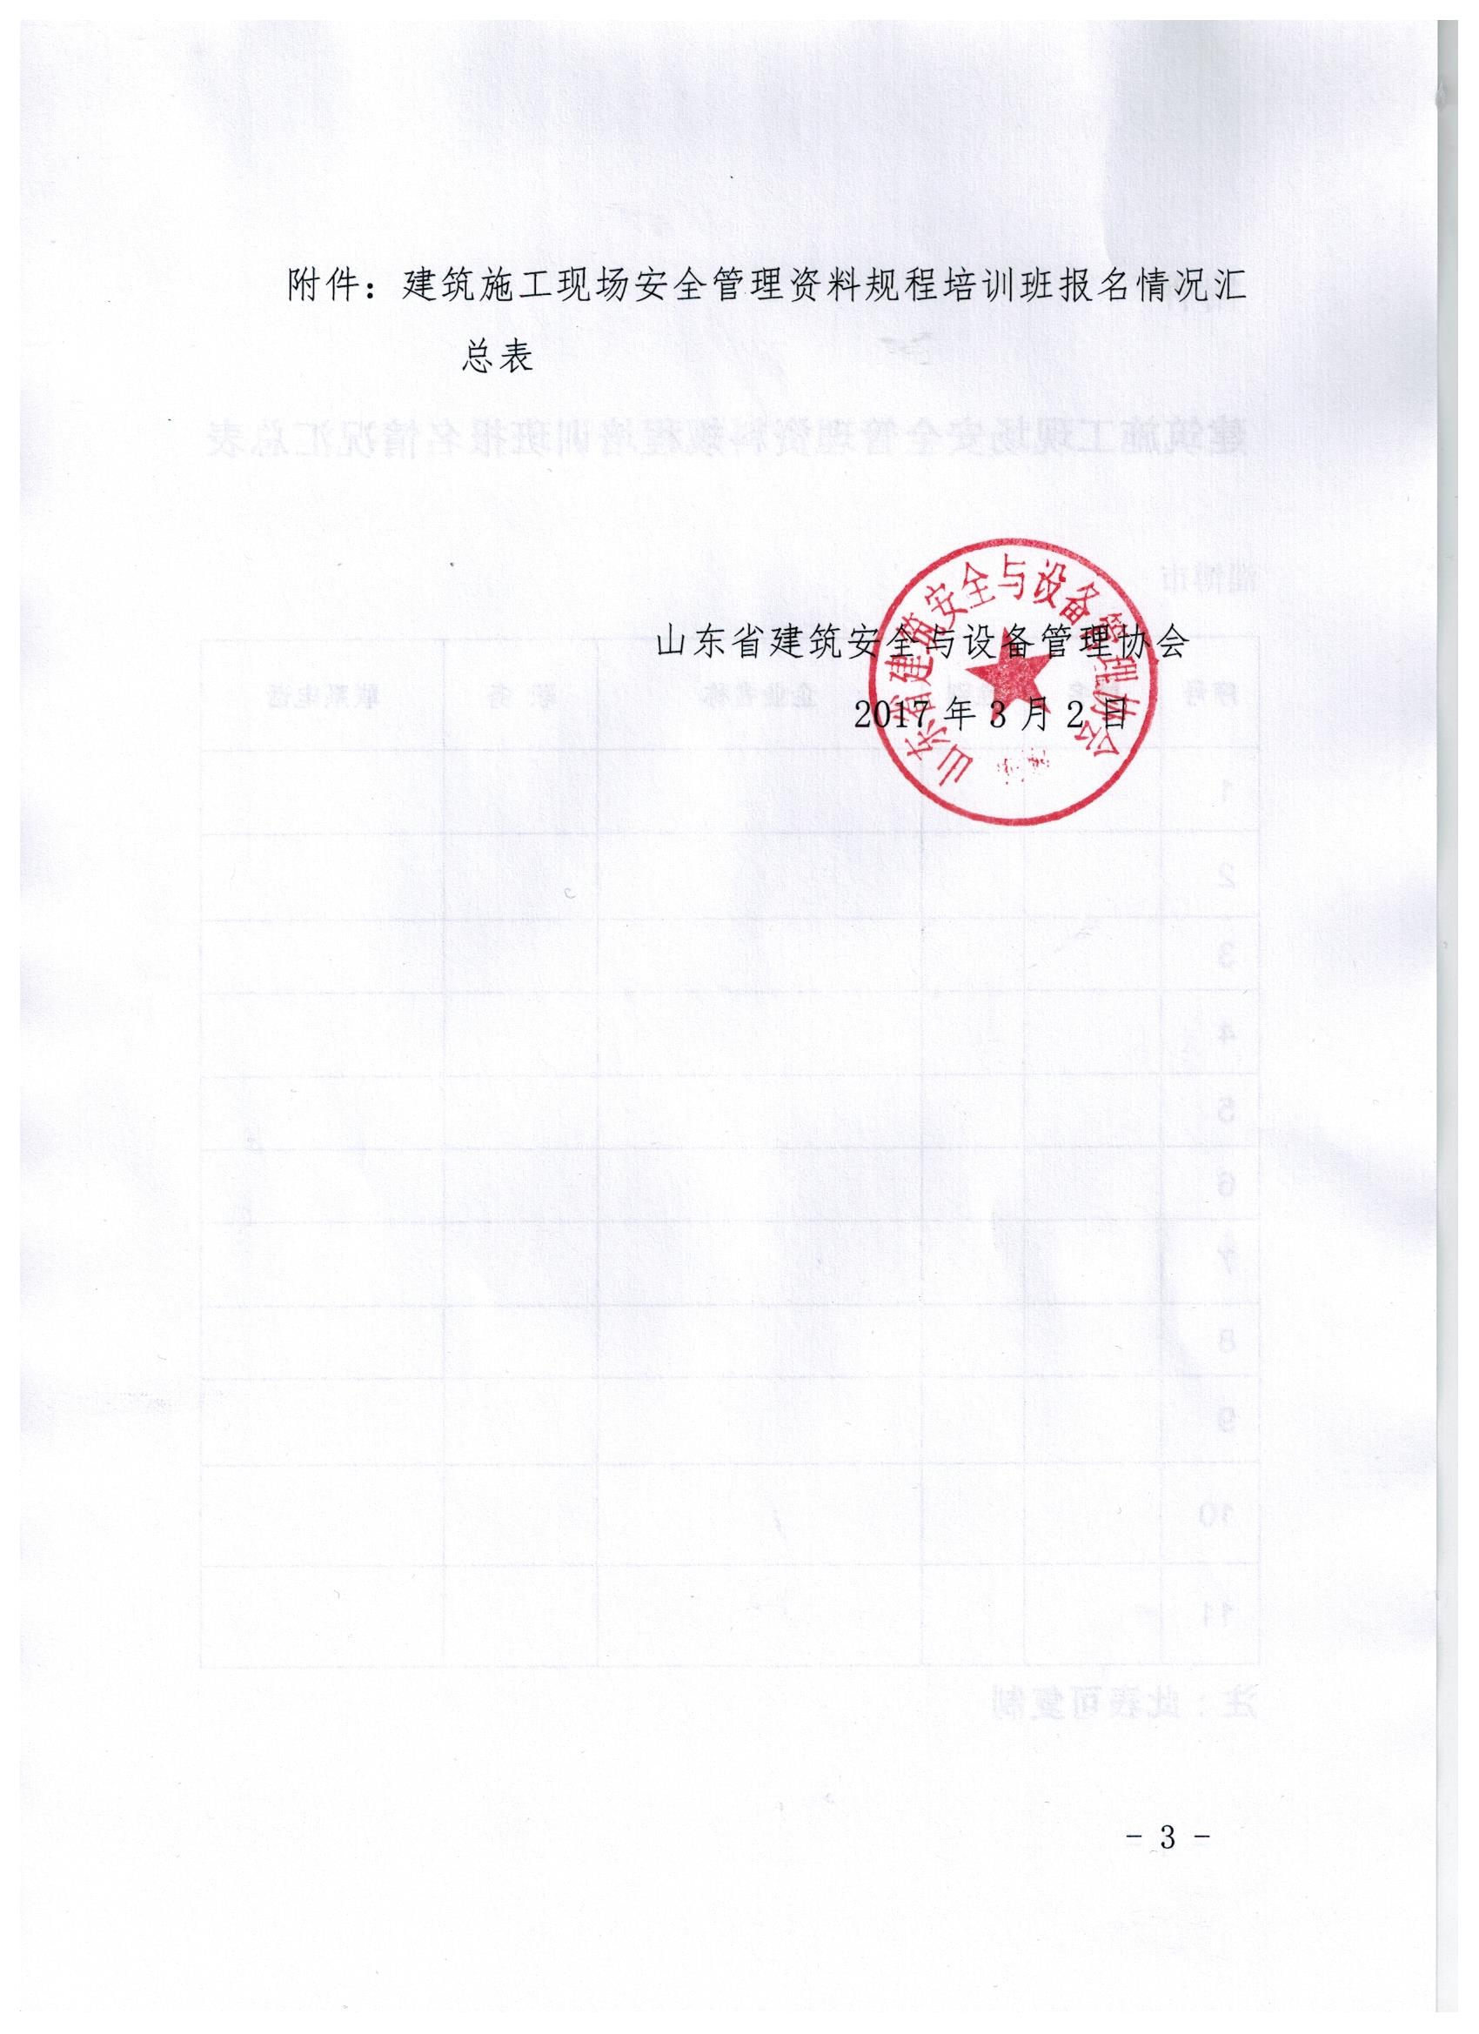

附件

**建筑施工现场安全管理资料规程培训班报名情况汇总表**

|  |  |  |  |  |  |
| --- | --- | --- | --- | --- | --- |
| 序号 | 姓名 | 性别 | 企业名称 | 职 务 | 联系电话 |
|  |  |  |  |  |  |
|  |  |  |  |  |  |
|  |  |  |  |  |  |
|  |  |  |  |  |  |
|  |  |  |  |  |  |
|  |  |  |  |  |  |
|  |  |  |  |  |  |
|  |  |  |  |  |  |
|  |  |  |  |  |  |
|  |  |  |  |  |  |
|  |  |  |  |  |  |

淄博市

注：此表可复制