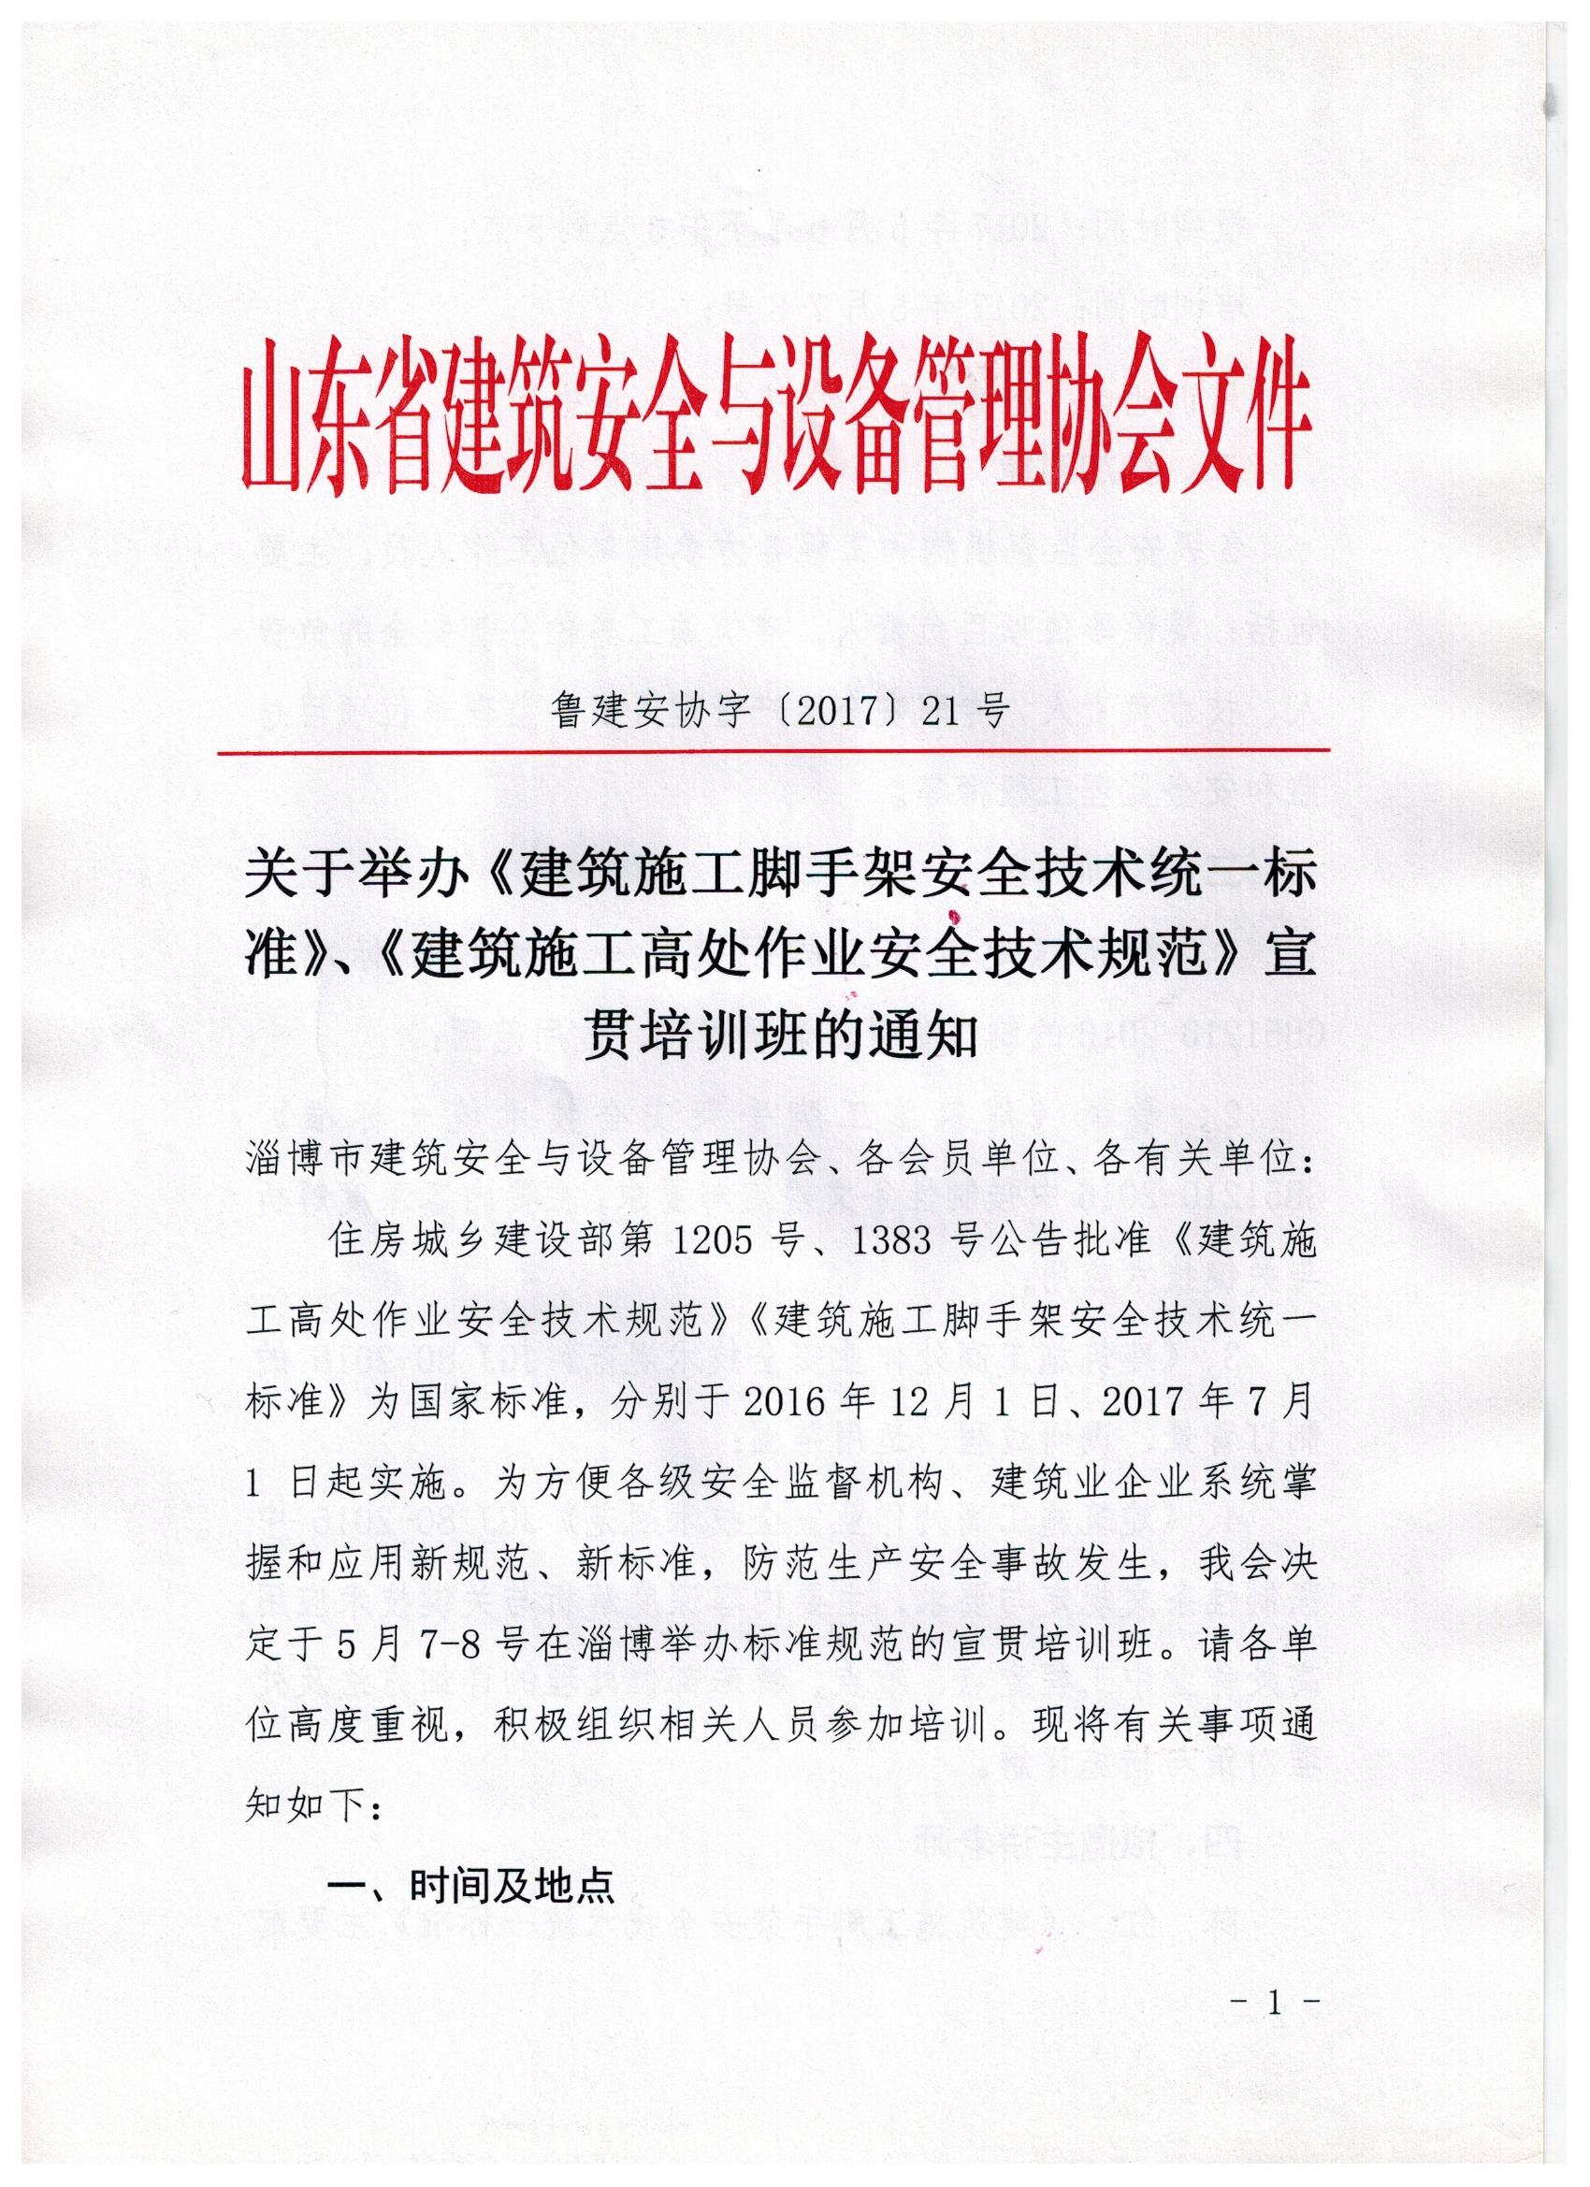

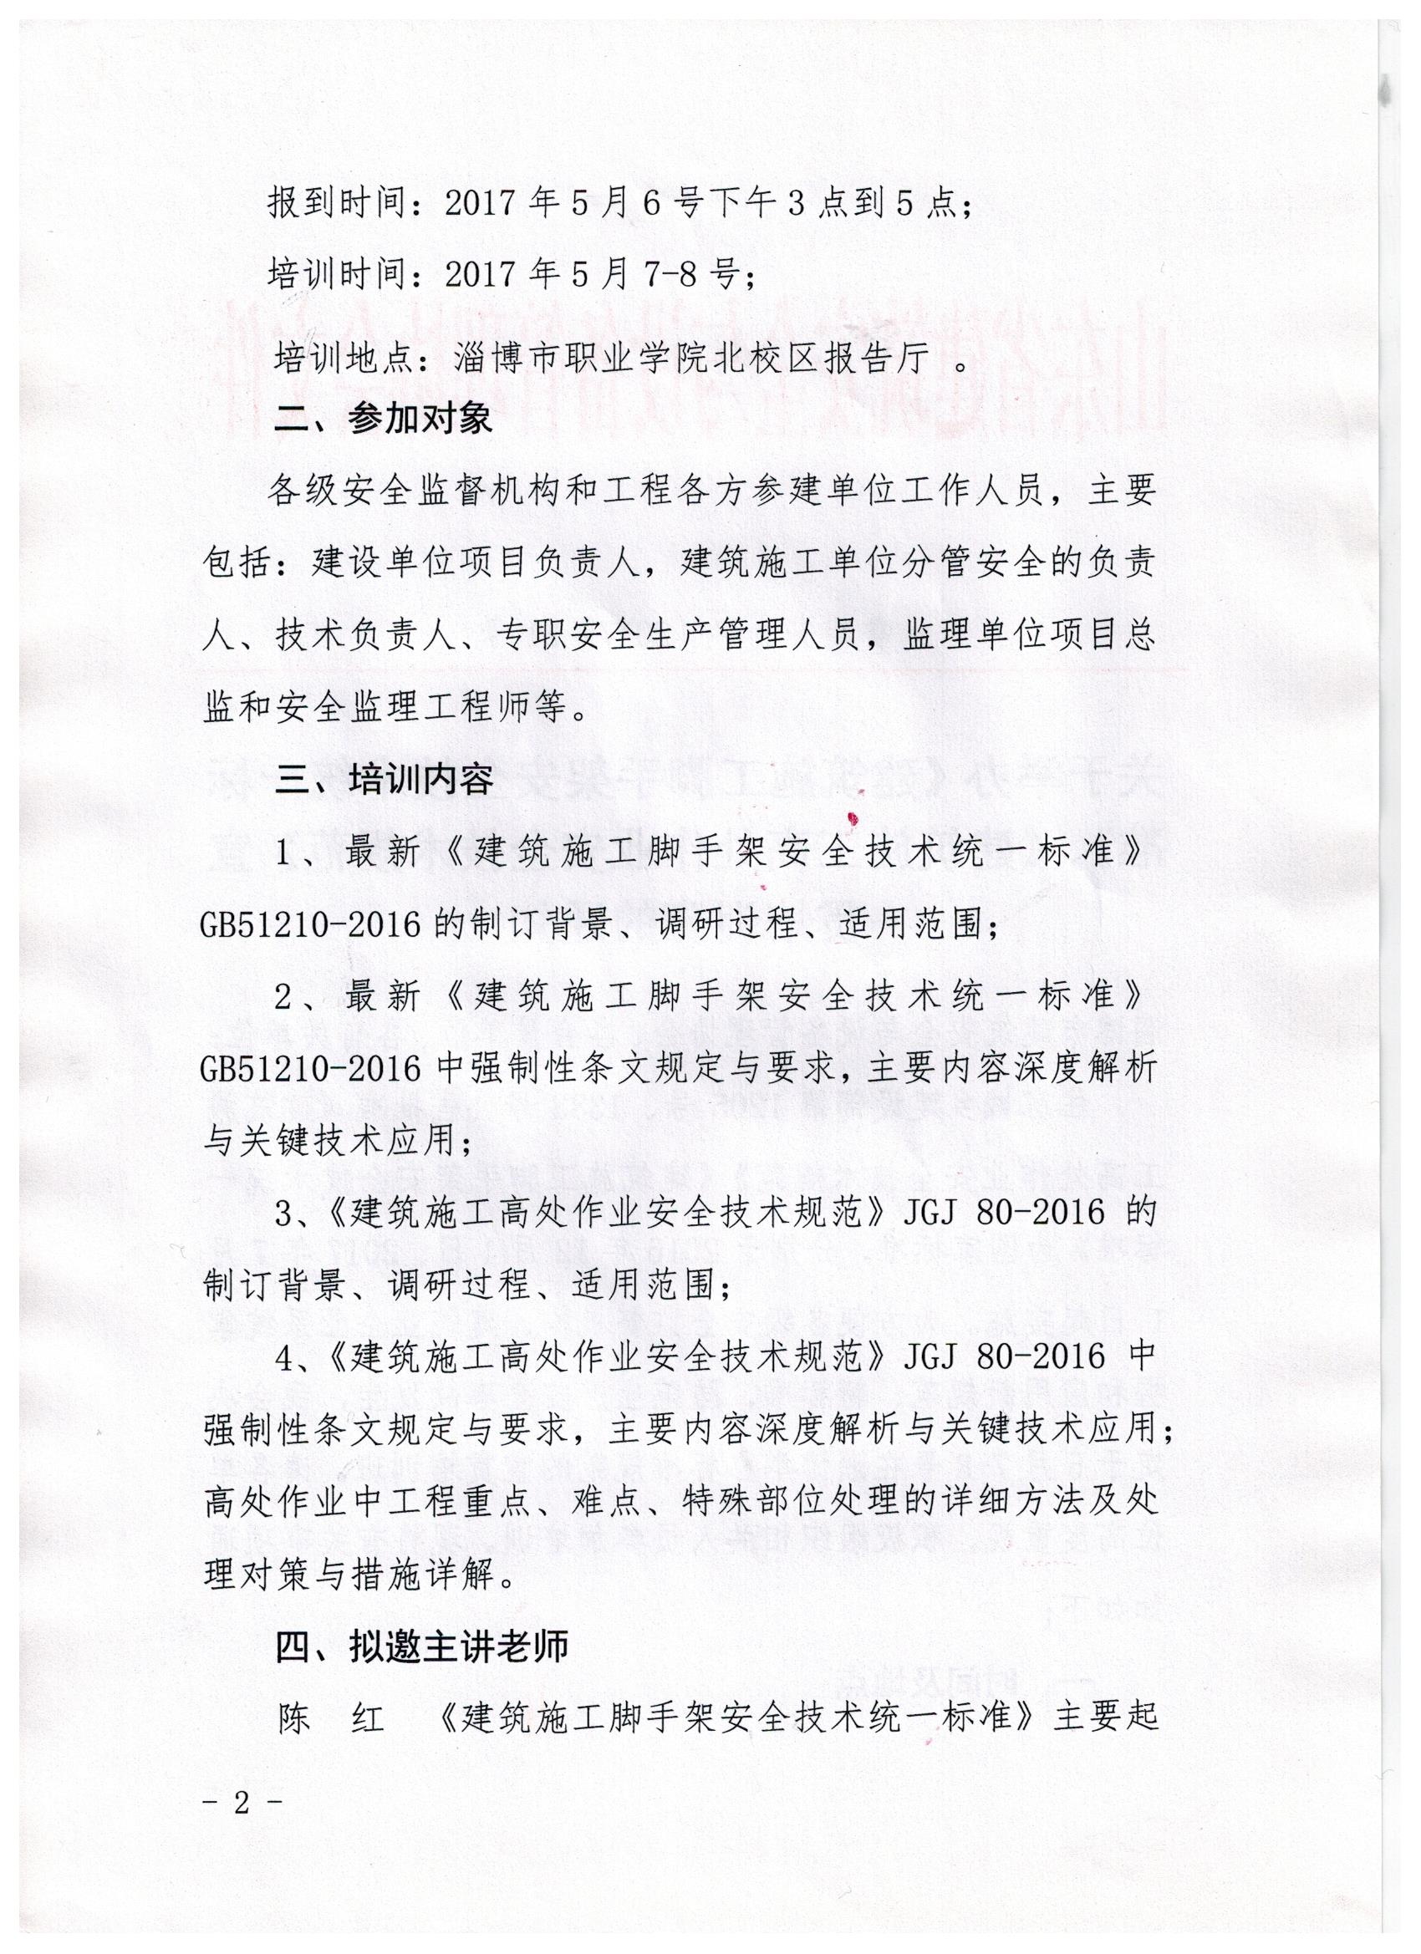

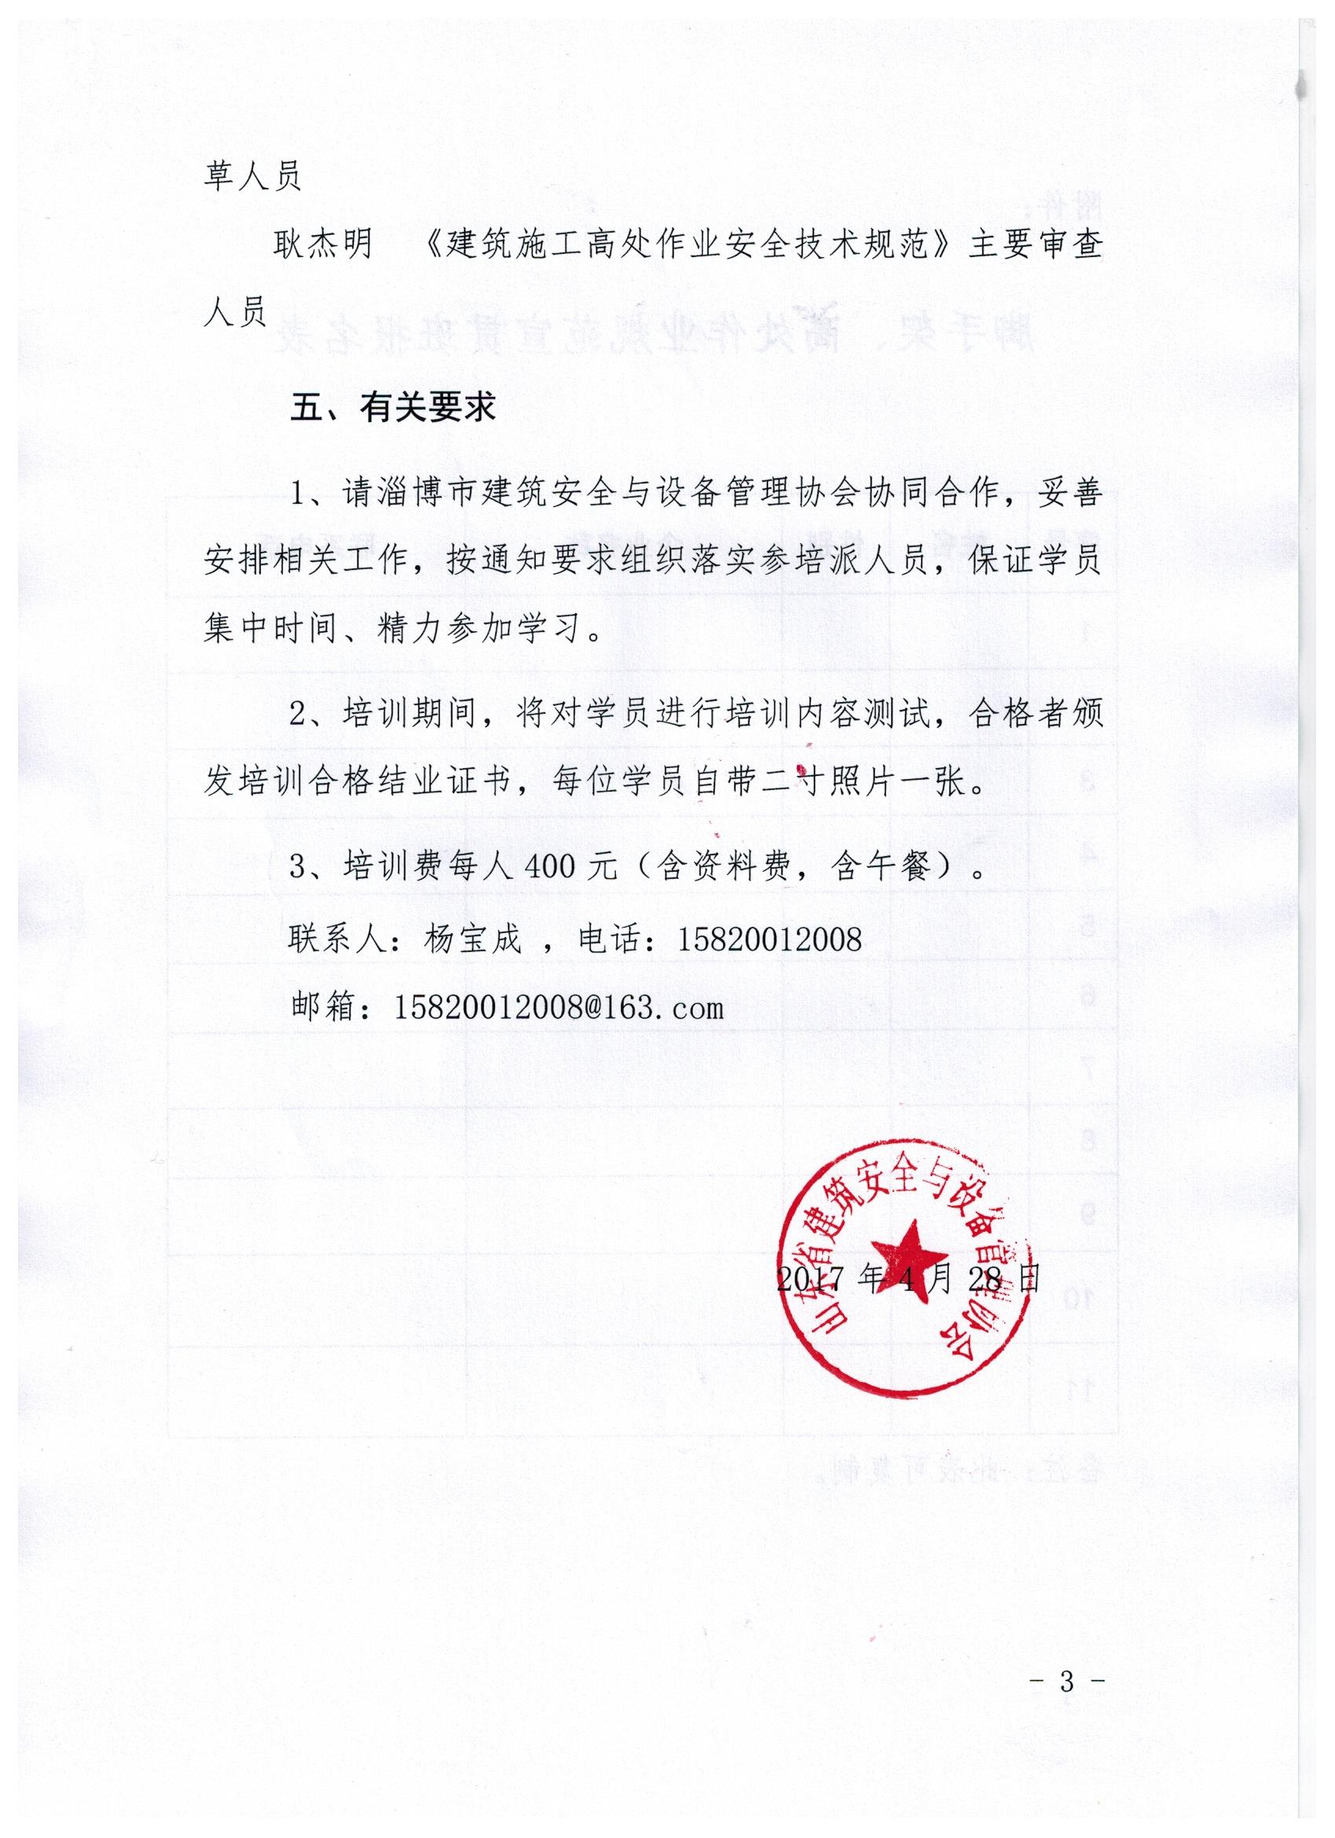

**附件：**

**脚手架、高处作业规范宣贯班报名表**

|  |  |  |  |  |
| --- | --- | --- | --- | --- |
| 序号 | 姓名 | 性别 | 企业名称 | 联系电话 |
|  |  |  |  |  |
|  |  |  |  |  |
|  |  |  |  |  |
|  |  |  |  |  |
|  |  |  |  |  |
|  |  |  |  |  |
|  |  |  |  |  |
|  |  |  |  |  |
|  |  |  |  |  |
|  |  |  |  |  |
|  |  |  |  |  |

备注：此表可复制。