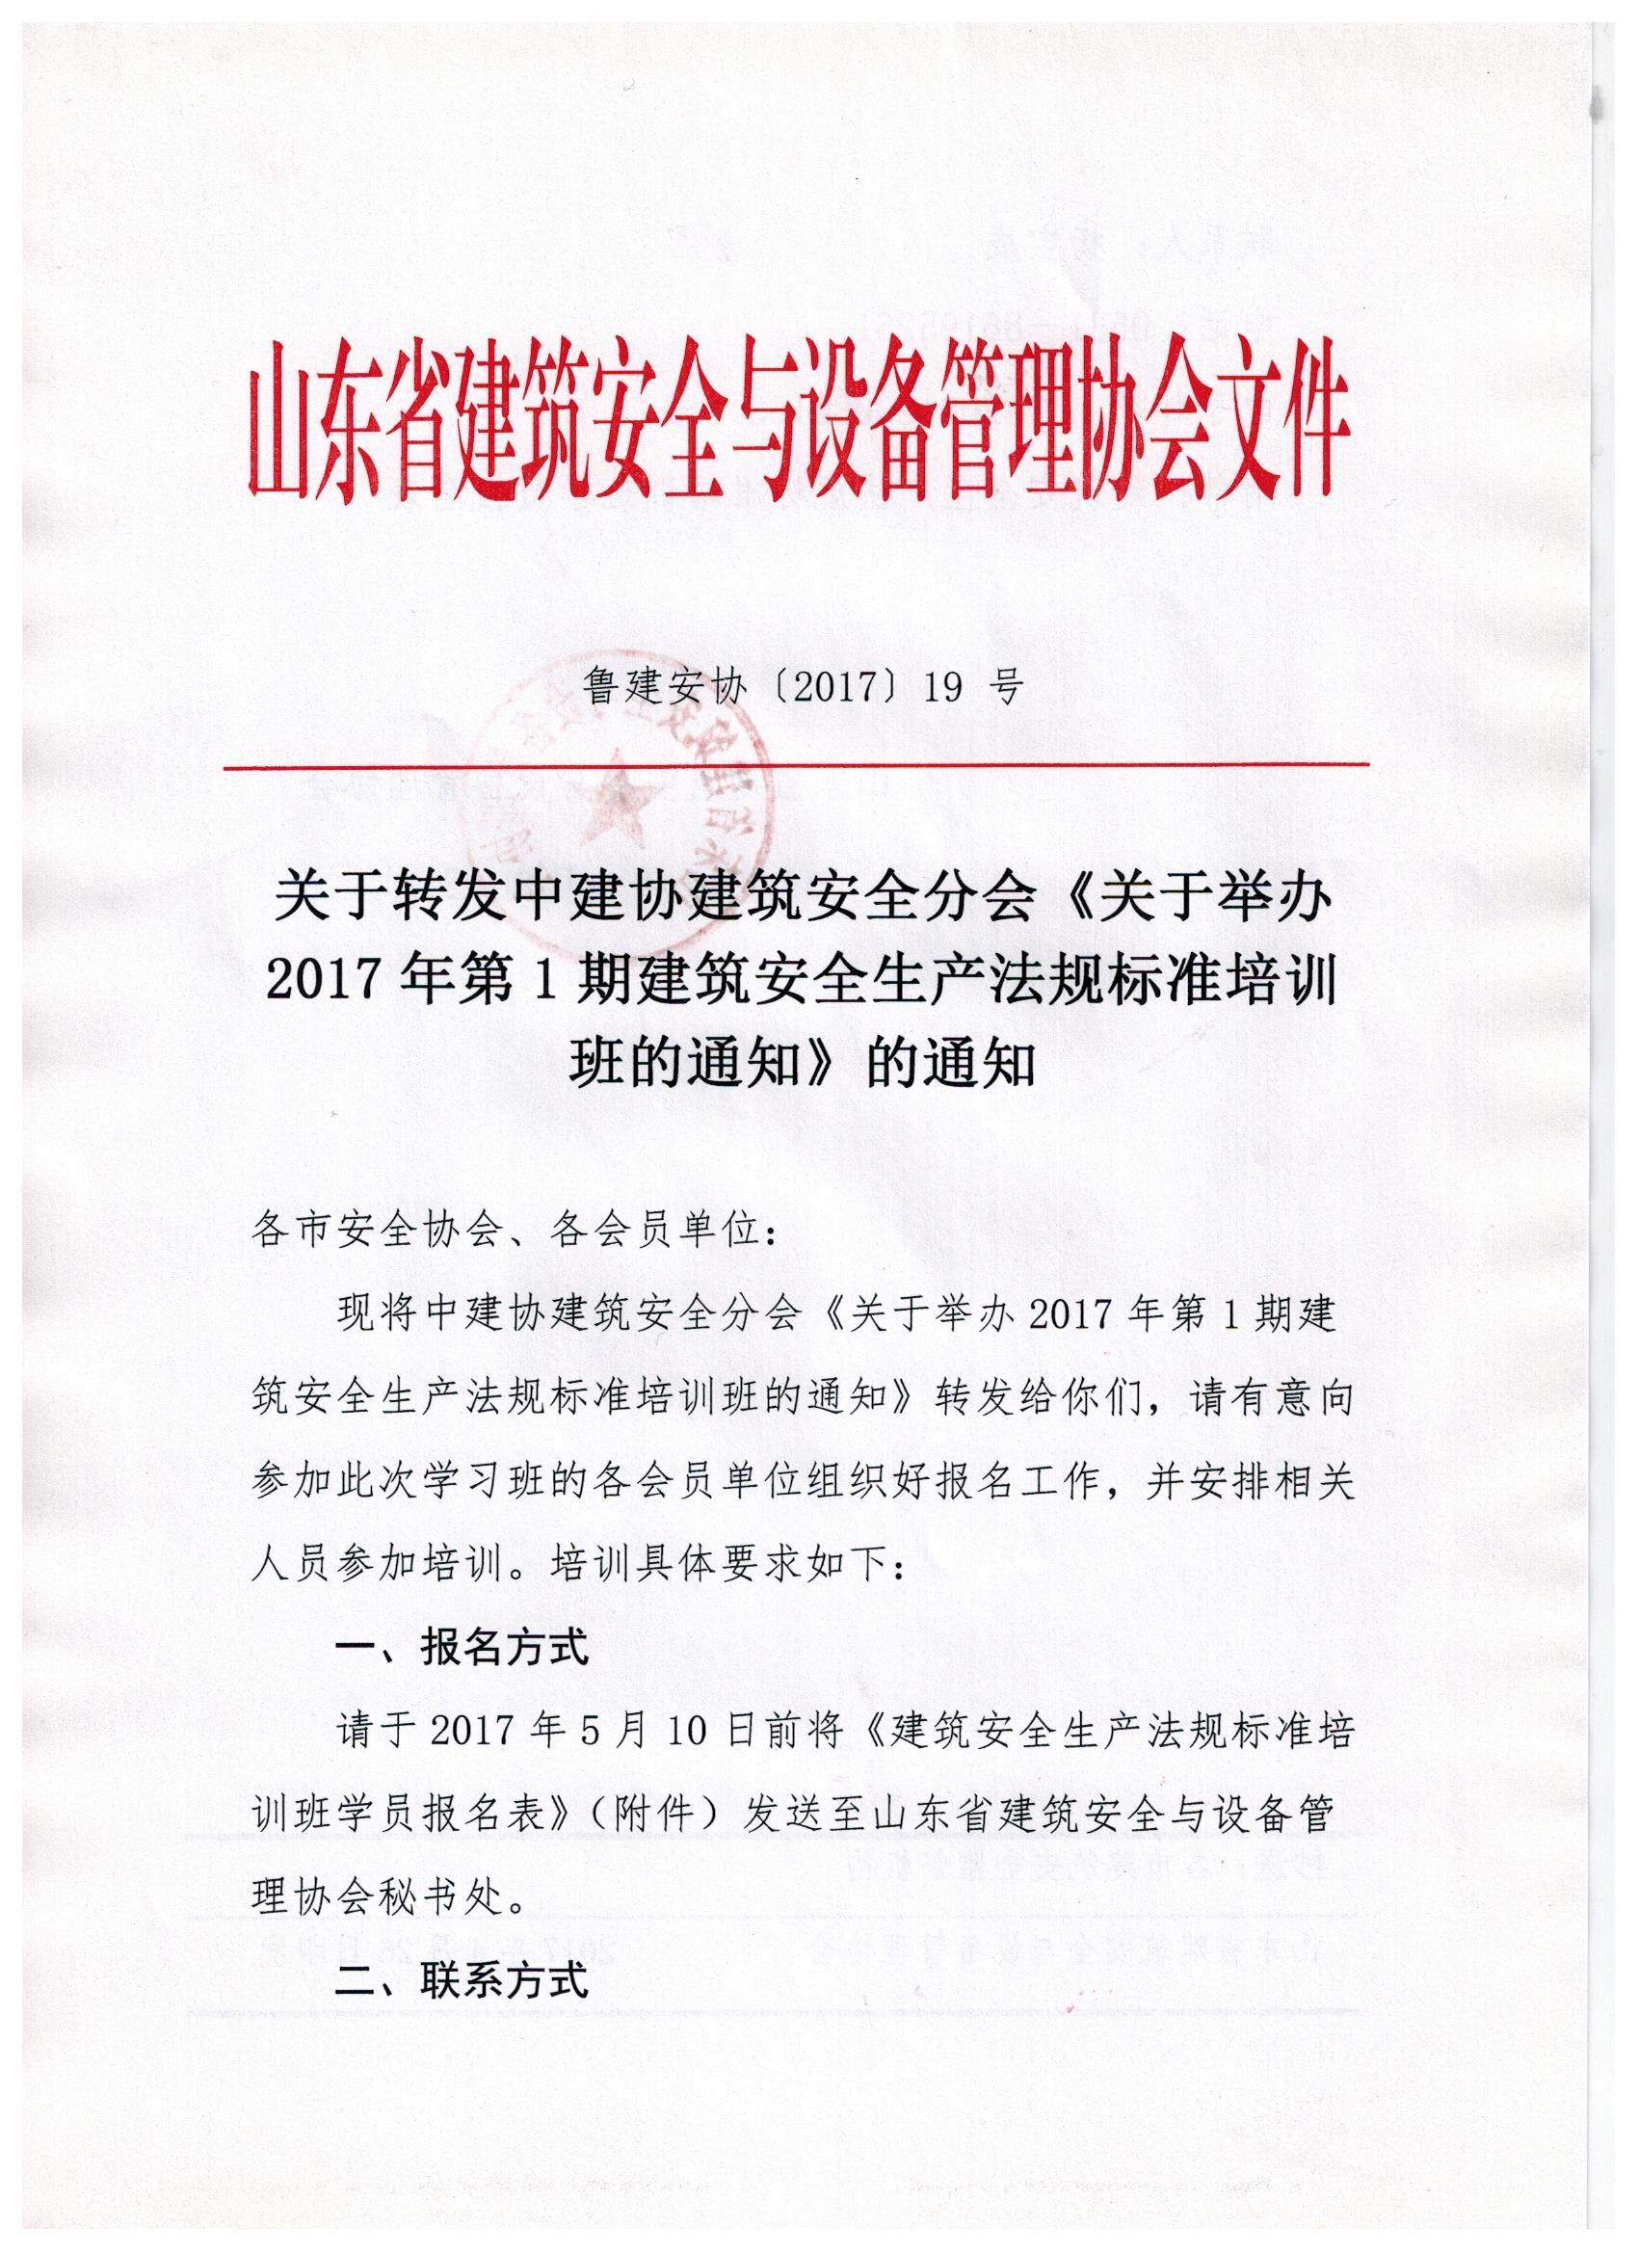

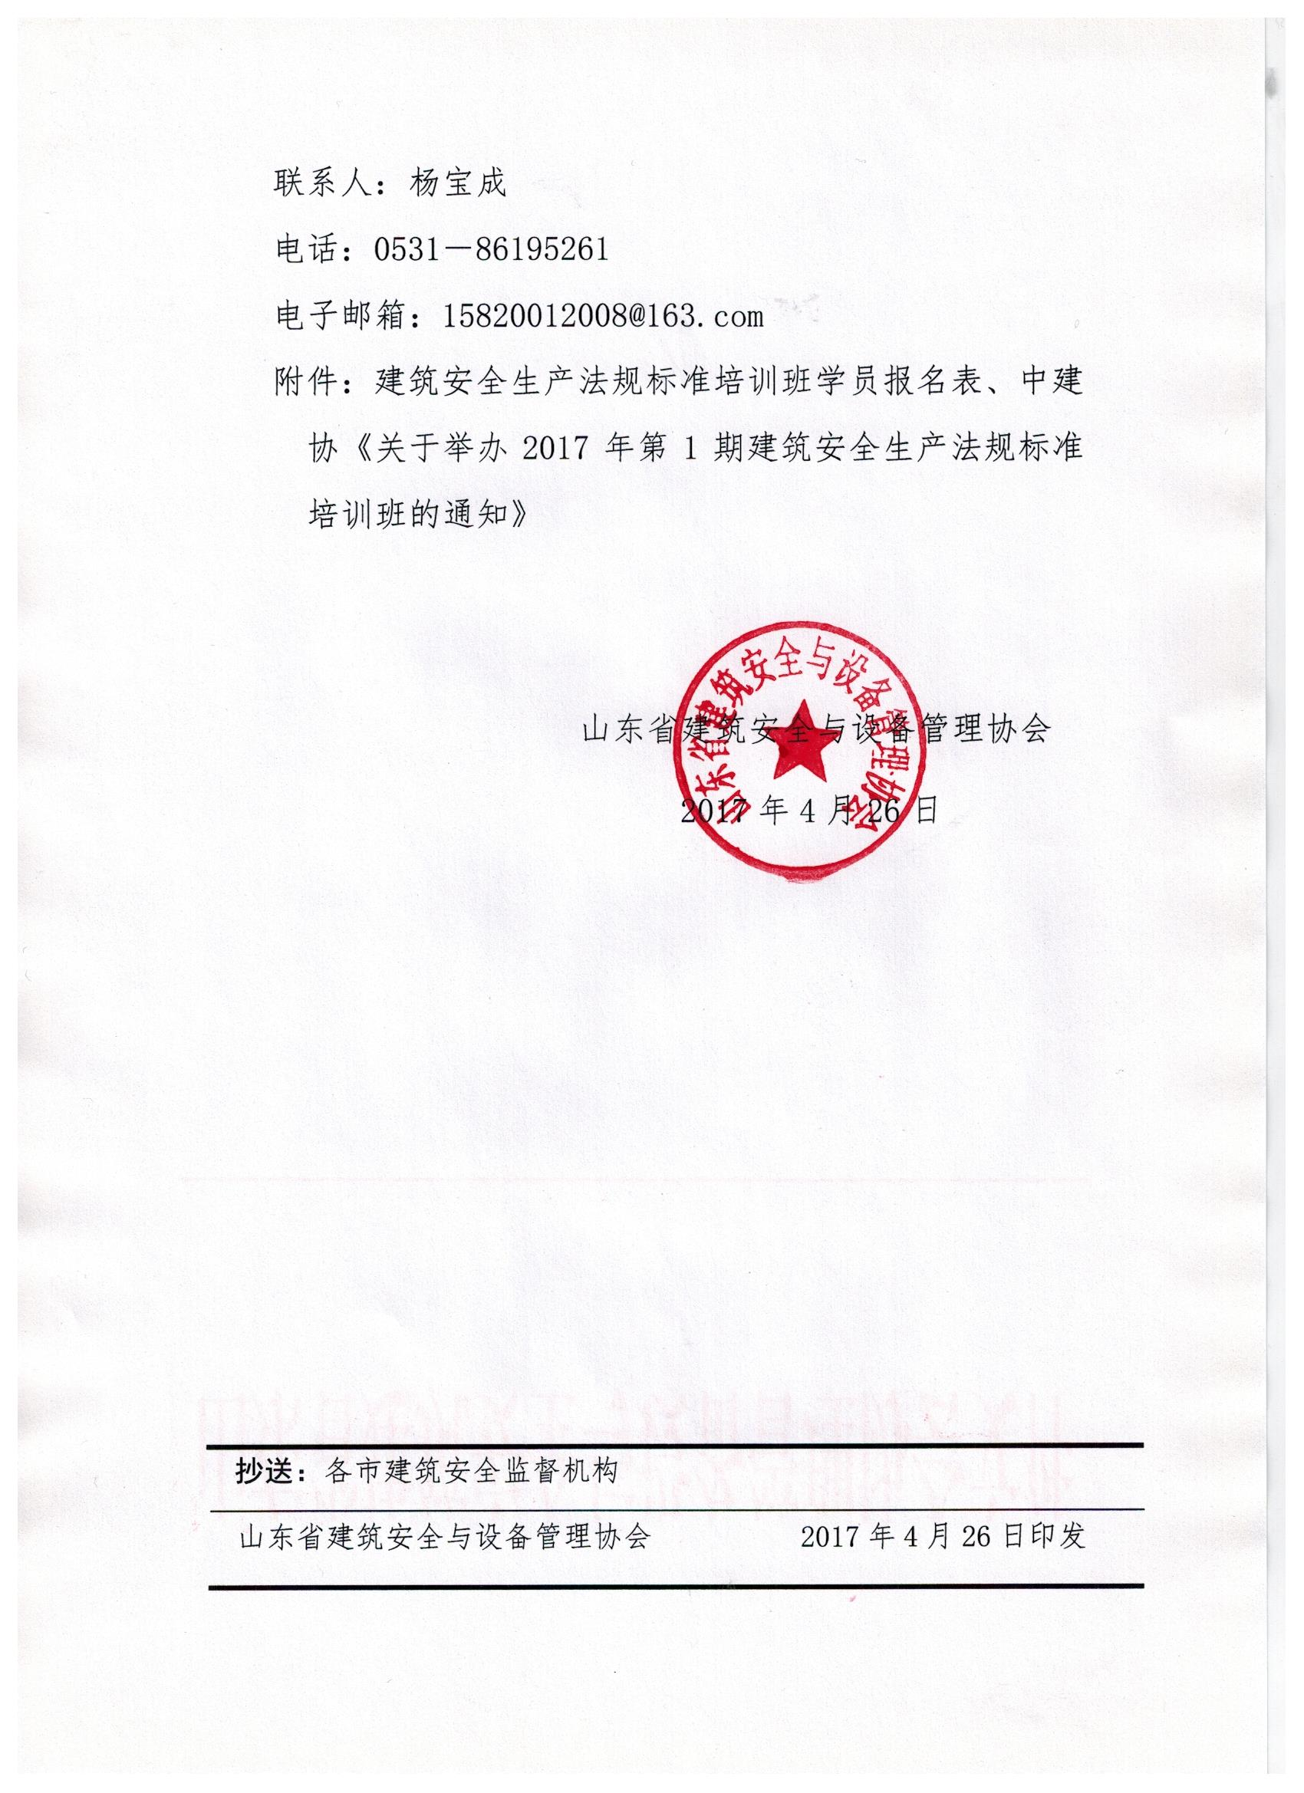

附件：

**建筑安全生产法规标准培训班学员报名表**

|  |  |  |  |  |
| --- | --- | --- | --- | --- |
| 序号 | 姓名 | 单位名称 | 联系电话 | 住宿（单住\合住） |
|  |  |  |  |  |
|  |  |  |  |  |
|  |  |  |  |  |
|  |  |  |  |  |
|  |  |  |  |  |
|  |  |  |  |  |
|  |  |  |  |  |
|  |  |  |  |  |
|  |  |  |  |  |
|  |  |  |  |  |

此表可复制

