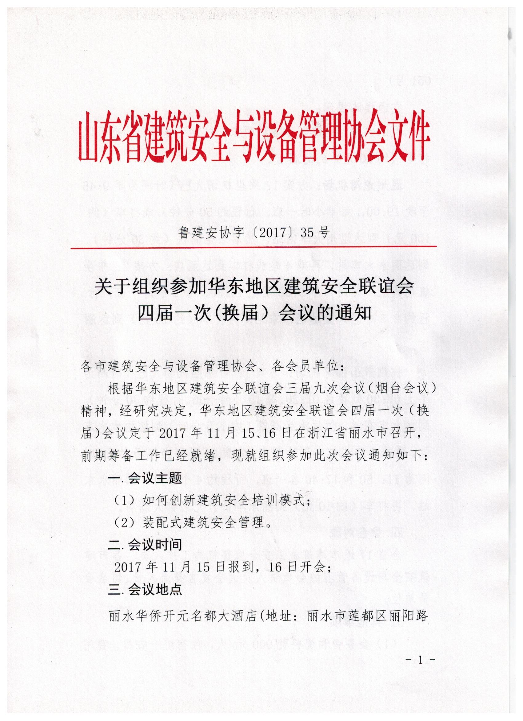

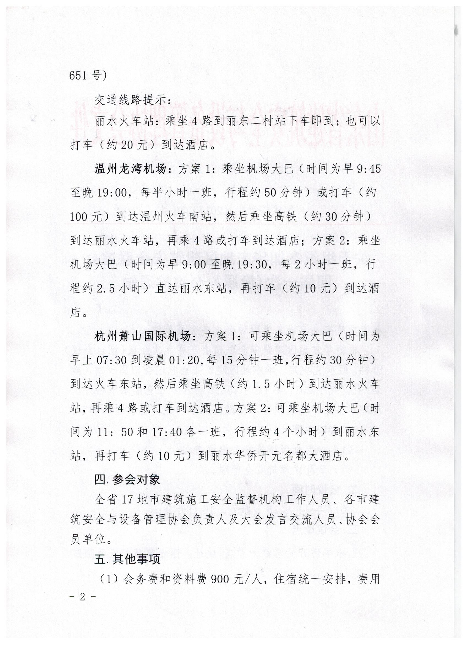

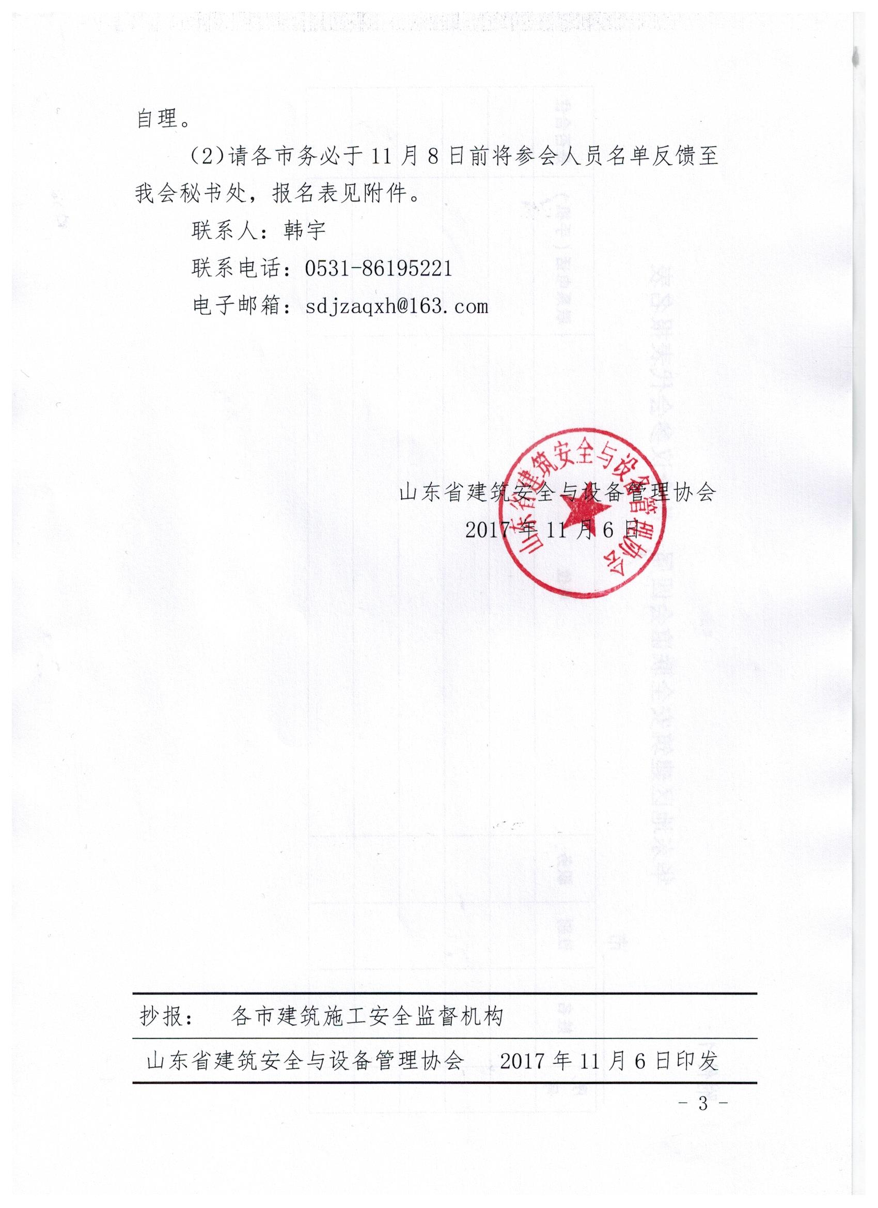

附件1：

|  |  |  |  |  |  |  |
| --- | --- | --- | --- | --- | --- | --- |
| **序号** | **姓名** | **性别** | **职务** | **单位** | **联系电话（手机）** | **是否合住** |
|  |  |  |  |  |  |  |
|  |  |  |  |  |  |  |
|  |  |  |  |  |  |  |
|  |  |  |  |  |  |  |
|  |  |  |  |  |  |  |

**华东地区建筑安全联谊会四届一次会议参会代表报名表**

市